How to register:

1. Go to www.easyfundraising.org.uk

2. Click on 'Create an account'

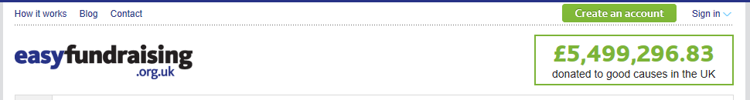

3. Click on 'I want to support a good cause'

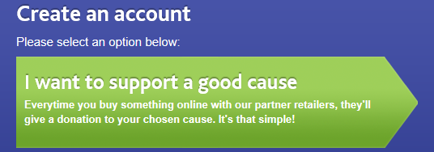

4. Type in Felbridge Primary School, then click 'Find'

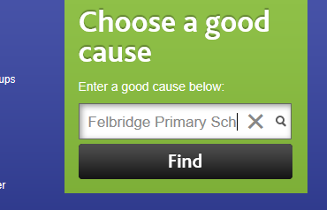

5. Click on 'Support'

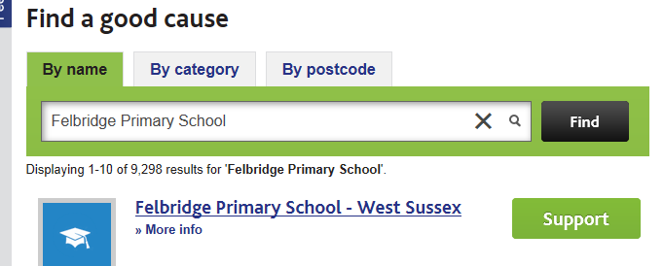

6. Enter your details and the go shopping!!

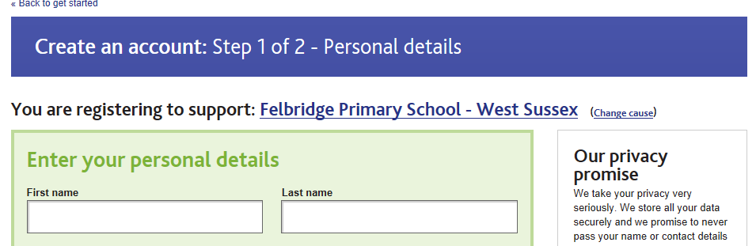

7. Don't forget to download the FIND AND REMIND tool, this will remind you to use Easyfundraising whenever you visit an affiliated site. Also, there is now an app, see attached leaflet to find out more.

